INADEQUATE
Pulse sequence
The one from the paper:
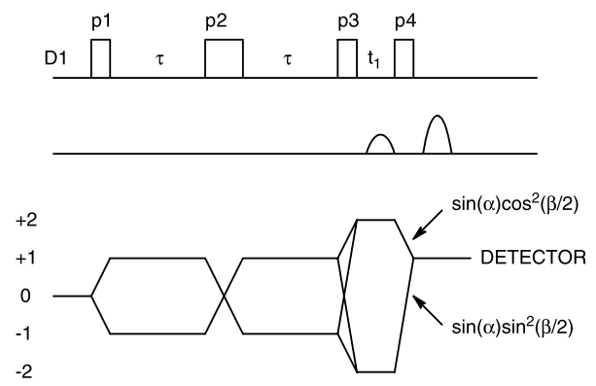
The one from the pulse sequence (inadqf) I found is a/the Bruker INADEQUATE sequence:
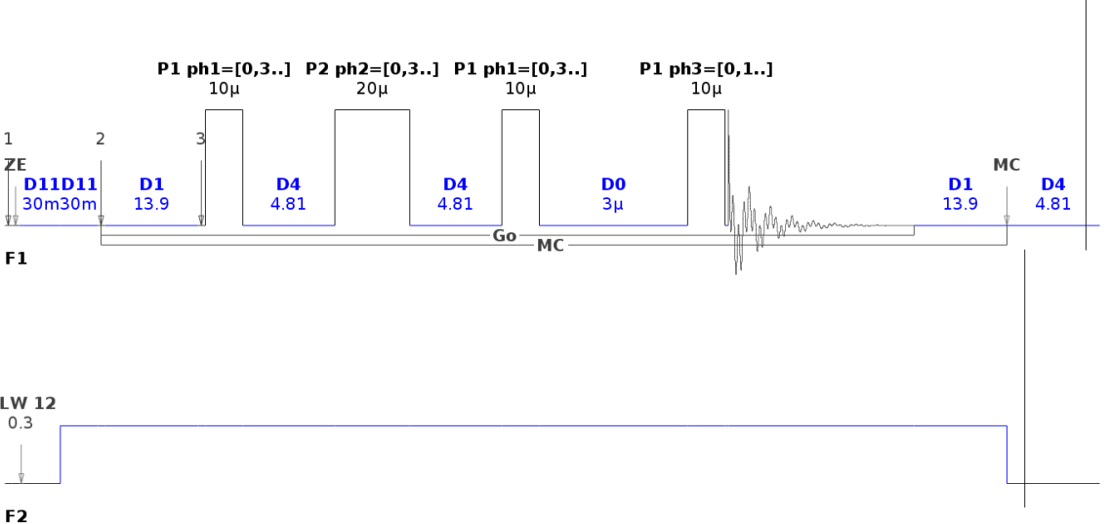

D4 = τ = 1 / (4 * J(C-C)) J(C-C) is typically about 50 us (with Acetate: ~52 us)
D1 = ~1.26 * T1 Normally, considering the shorter T1 is enough (e.g., 11 & 45 s -> 11 s)
D0 = t1 = incremented delay for 2D
180°-refocusing pulse seems to be a “weak link”

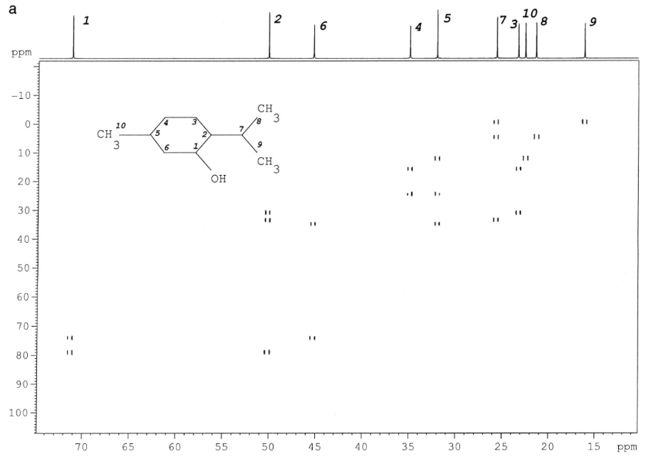
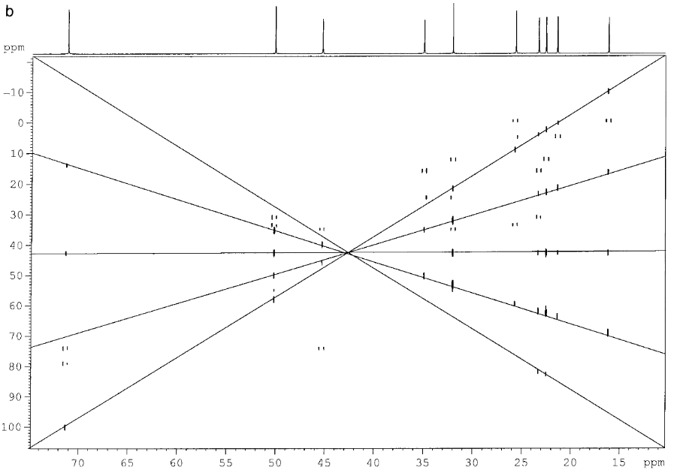
Single and double quantum artifacts produced by a to short interscan delay (a: 4 s, b: 0.7 s)
Could also be suppressed if shortening should be needed.
Natural Abundance, Single-Scan 13C−13C-Based Structural Elucidations by Dissolution DNP NMR
Martins Otikovs, Gregory L. Olsen, E̅riks Kupče and Lucio Frydman
(J. Am. Chem. Soc. 2019, 141, 1857-1861)

1D -INADEQUATE with D-DNP
- same information content as 2D
- high demands on spectral quality for unambiguous identification of interactions

